Wanted
Dead or Eaten
For Home invasions, property damage, & aggravated assault
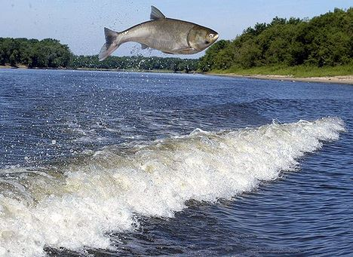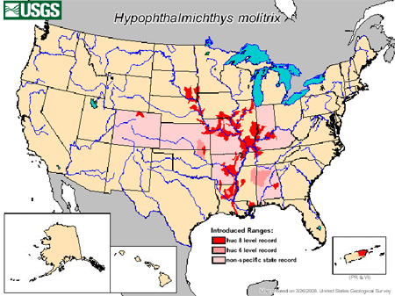
Asian Carp aka The “Jumping” carp
Reward: the Great Lakes’ commercial, tribal, and sport fisheries, valued at more than $7 billion will not be destroyed, Native fish can live and thrive in peace, and the Great Lakes Food Web would be back in order------ Great tasting Carp chop sushi
Identifying suspect: eyes low on face below midline of fish, large head, big mouth, line or ridge on bottom called keel
Hide outs/ last seen: Mississippi River, Illinois River, Missouri River
Origin: Asian carp were originally imported from Southeast Asia to the southern United States, Flooding allowed these fish to escape into the Mississippi River system and migrate into the Missouri and Illinois rivers.

